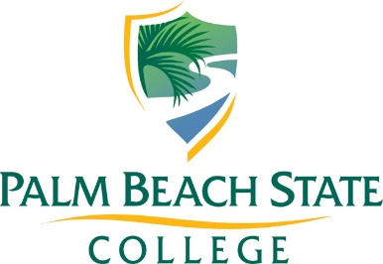
Florida Partnership for Minority &
Underrepresented Student Achievement Grant

Year 3 Statement of Work Template

School District:
Primary Contact:
Email: | Phone:
Secondary Contact:
Email: | Phone:

1. Project Overview
Briefly describe the project, including the main objectives, targeted issue, and the overall scope.

2. Goals
- Identify the goals of the program. Goals are general statements about the purpose of the program (e.g., improve teacher knowledge of AP course curriculum).
Goal 1:

Goal 2:

Goal 3:

Goal 4:

3. Objectives
Detail the specific objectives of the project using the “SMART” model”: Specific, Measurable, Achievable, Realistic, and Time-Framed (see attached tips for writing SMART objectives).
Objective 1:

Objective 2:

Objective 3:

Objective 4:

4. Deliverables
Provide detailed descriptions of all the deliverables the project will produce.
Deliverable 1:

Deliverable 2:

Deliverable 3:

Deliverable 4:

5. Timeline
Provide a detailed project timeline including start and end dates for each deliverable.

6. Project Team
List all team members involved in the project, including their role and responsibility, and contact information.
Name | Contact | Role & Responsibility

7. Budget Narrative
Provide a detailed, narrative breakdown of your budget by cost category and item (see Sample Budget Narrative).

7. Monitoring Activities
Describe the oversight processes put in place to ensure that the program is implemented with fidelity and appropriate documentation is collected and maintained.

