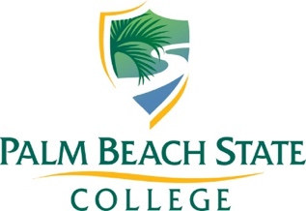
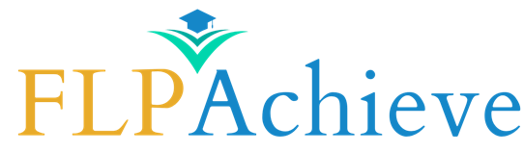

Q3 Reporting Dates: January 1, 2026 – March 31, 2026

Subrecipient:
Primary Contact:
Email: | Phone:
Secondary Contact:
Email: | Phone:

I. Project Summary
The goal of the FLP Achieve Program is to prepare, inspire, and connect all students to postsecondary success and opportunity, with a particular focus on minority students and students who are underserved in postsecondary education.
Funding purpose and priorities includes 1) the delivery of teacher training and professional learning to increase the number of students enrolled in advanced courses, 2) the increase of the number of students who successfully complete and pass advanced course examinations; and 3) the improvement of the skill level and ability of students at the level that will prepare them for the admission and completion of a postsecondary education.
Provide a brief summary of how your grant has contributed to the fulfillment of this goal.

II. Program Outcomes
Provide details on the status of each objective listed in your Statement of Work and their outcomes.
*If applicable, indicate the type of professional development offered and number of individuals who participated.

Objective 1:

Objective Status: ☐Completed ☐Partially Completed ☐Postponed ☐ Not Completed

Outcomes:

Schools Impacted:

Funds spent this quarter on Objective 1:

Objective 2:

Objective Status: ☐Completed ☐Partially Completed ☐Postponed ☐ Not Completed

Outcomes:

Schools Impacted:

Funds spent this quarter on Objective 2:

Objective 3:

Objective Status: ☐Completed ☐Partially Completed ☐Postponed ☐ Not Completed

Outcomes:

Schools Impacted:

Funds spent this quarter on Objective 3:

Objective 4:

Objective Status: ☐Completed ☐Partially Completed ☐Postponed ☐ Not Completed

Outcomes:

Schools Impacted:

Funds spent this quarter on Objective 4:

Objective 5:

Objective Status: ☐Completed ☐Partially Completed ☐Postponed ☐ Not Completed

Outcomes:

Schools Impacted:

Funds spent this quarter on Objective 5:

* You may add additional objectives as necessary
III. Challenges
What were some of the challenges you faced while implementing your project this year?

IV. Successes
What were some of the successes of your project this quarter?

V. Other
Is there anything else you would like us to know?

Please Upload Secure Documents via Smartsheet here no later than April 15, 2026.

